Bridgepoint Parts Catalog

Section XII: Pressure Regulators Page 1

PHY169-101

Pressure Regulator

Hydramaster: Most older truck mounts. CDS 4.6 & CDS 4.8.
Bridgepoint: Dagger
Repair Parts:
Spring & O-ring Kit: PHY078-101
Rebuild Kit: PHY078-102
O-ring Kit: PHY097-028
1000 PSI Spring: PHY155-021

PP15-808068

Pressure Regulator

Prochem: Apex, Performer, Performer 405, Bruin, Bruin II, Everest, Legend & Legend SE.
Performer 805 (Low-pressure side)
Everest HP (Low-pressure side)
Blueline: Bluewave, Champ &
Thermal Wave 5M
Bridgepoint: Lancer & Lancer II
Hydramaster: Boxxer 318, Boxxer 427, CDS 4.6, CDS 4.8 & Titan 575
Repair Parts: Rebuild Kit: PP16-808200
O-ring Kit: PP16-808201
White Spring: PCA32090
(150-1450psi)
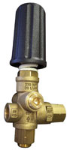
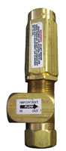

PHY169-083 Pressure Regulator

Hydramaster: Maxx 550, Maxx 450D, Maxx 470D & Boxxer 421.
Bridgepoint: Javelin
Repair Parts:
Rebuild Kit: PHY078-274

For old style regulator with tapered handle on early Maxx and Javelin units. Use repair kit PHY078-273
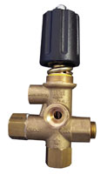

PCA7672

Pressure Regulator – Unloader

Prochem:
Performer 805 (High-pressure side)
Everest HP (High-pressure side)
White Magic: All truck mounts. Hydramaster: Titan 875

Repair Parts:
Rebuild Kit: PP16-808200
O-ring Kit: PP16-808201
Blue Spring: PCA32092
(850-3200psi)

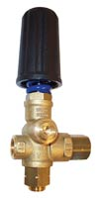

PGR03

Pressure Regulator

I Incoming Water

Used on many different truck mounts to control incoming water pressure to the machine. Reduces incoming pressures as high as 300psi down to 3-50psi.
Hydramaster: Old style Hydracat without mix tank.
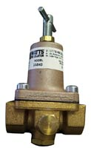

PP15-808081

Pressure Regulator - Suttner

Prochem: Blazer, Blazer Plus, Blazer XL, Oil Fired TM,
Legend XL, Peak, Trailblazer &
Cub XL
Can be used as an upgrade for 100A, 150, Cub and 800A. Regulator Upgrade Kit PP66-945115.
Bridgepoint: System IV & Saber.
Repair Parts:
Rebuild Kit: PP16-808193
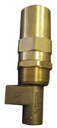

PCA7550

Pressure Regulator

CAT 1LX Pump

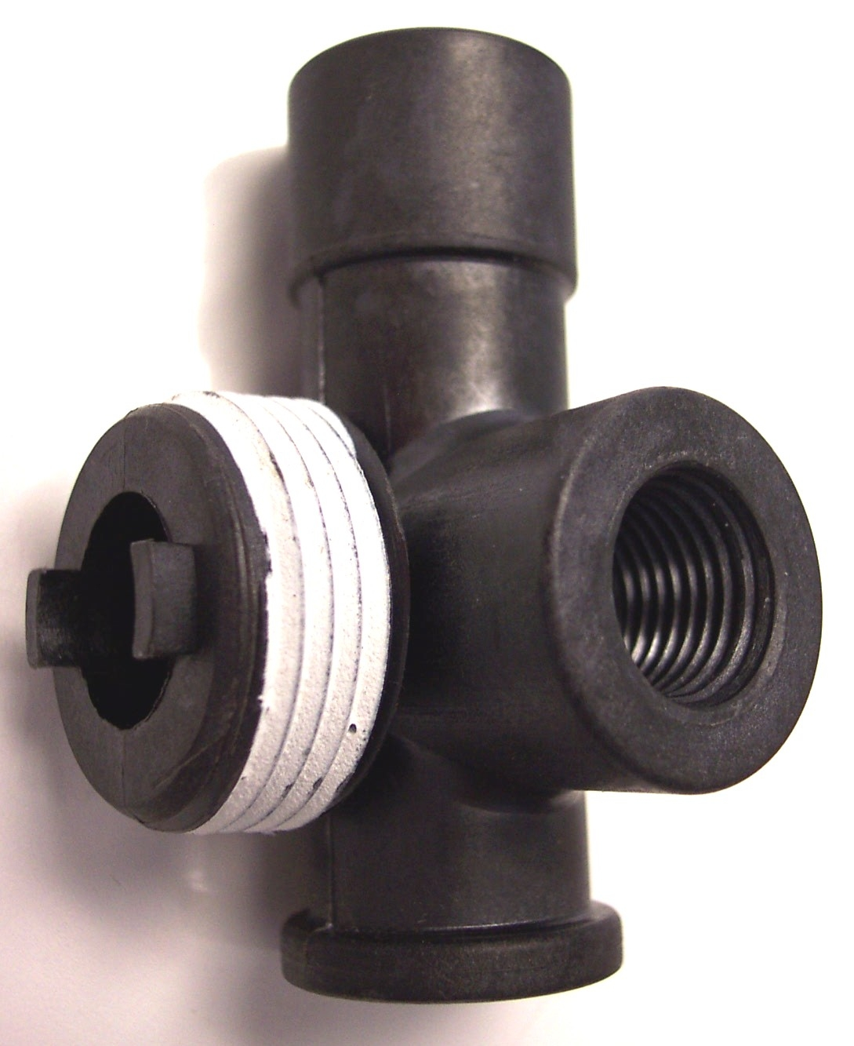

PS6815

Pressure Regulator
Spraying Systems 1200PSI
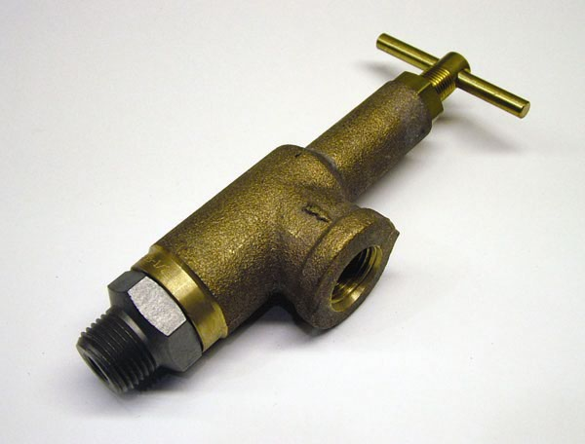

PM715000

Mini Pressure Regulator
Old Style FX88 & Truck Force
Repair Parts: Piston: PM715001
O-ring: PM715002

PP15-808078

Pressure Regulator
Prochem: Cub
Bridgepoint: Older System IV
Rebuild Kit: PP15-808078A

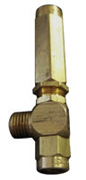

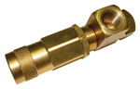

Bridgepoint Parts Catalog

Section XII: Pressure Regulators Page 2

PT020

Pressure Regulator – 200PSI

Blue Spring
Old Style Force 250 Pump
Rebuild Kit: PT020A

PT021

Pressure Regulator – 500PSI

Silver Spring
Olympus: M3-500 & M500H
Hydro-Force: New Style FX88
Rebuild Kit: PT020A
SS Seat: PT021SS
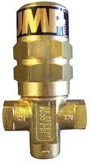

PT019

Pressure Regulator – 1200PSI
Olympus: M1200
Hydro-Force: FXHP (old style)

Repair Kit: PT019A
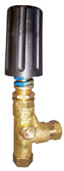

PT048

Pressure Regulator – 200PSI

Pumptec 114 – Force 250
Olympus: M200, M200H &
M3-200H
Used as pressure relief valve on Olympus M100H

Repair Kit: PT048A

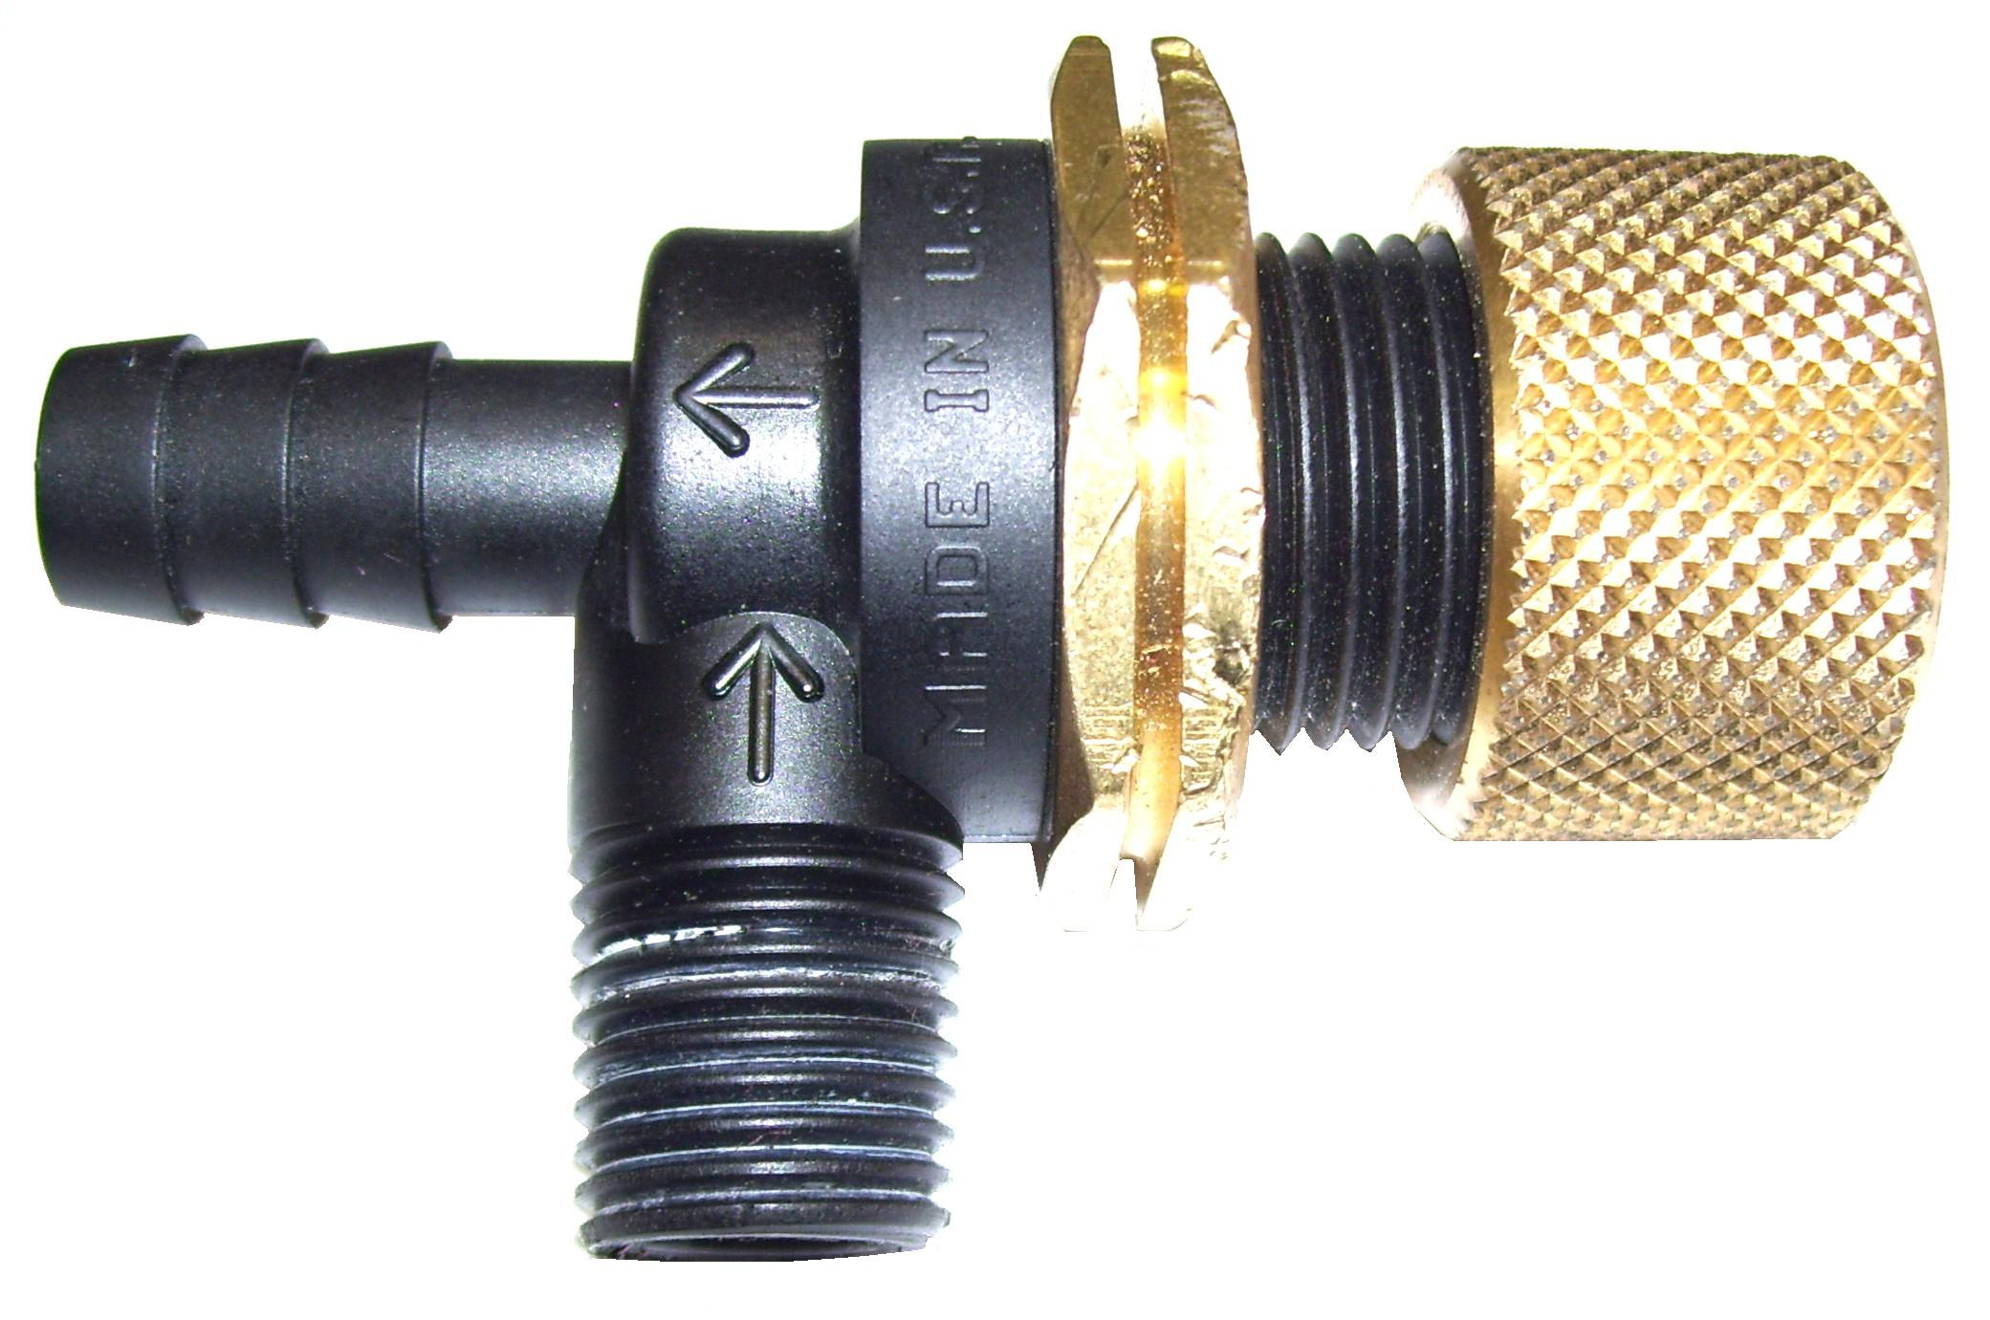
DISCONTINUED – USE PT016

PT017

Pressure Regulator – 1200PSI
Nautilus: MX-1200 & MX3-1200
Hydro-Force: AS1200 &
FX88HP (new style)
Seal Kit: PT017KIT
Knob: PT017KNOB

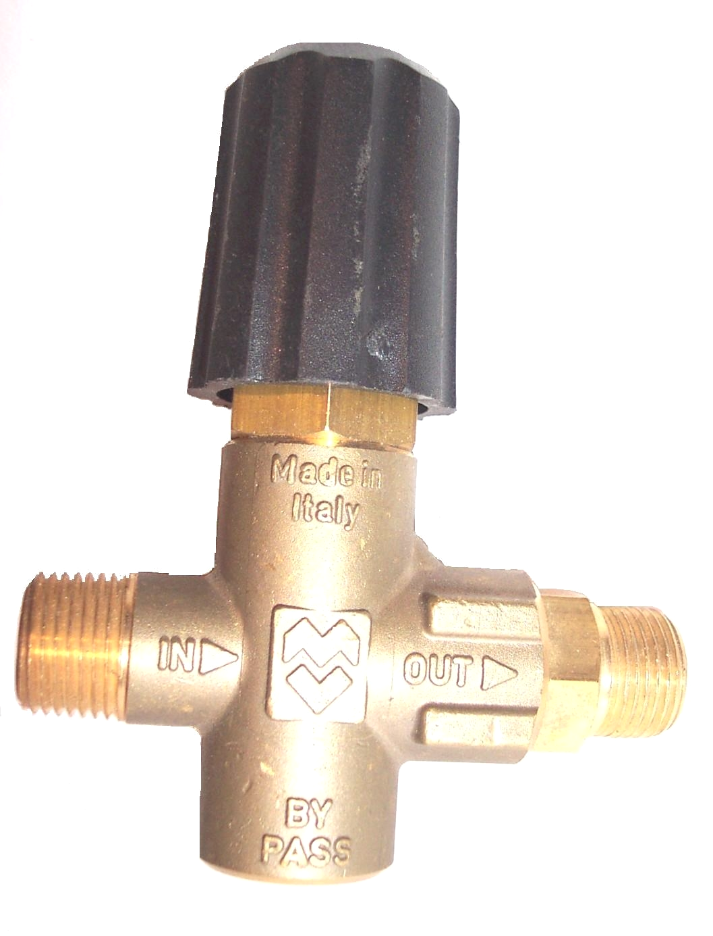

PT067

Pressure Regulator – 250PSI

Repair Kit: PT048A

Used as pressure relief valve on Olympus M200H, MX150H,
& M3-200H equipped with AP170 or AP220 pumps.

PT017B

Pressure Regulator – 500PSI
Nautilus: MX500 & MX3-500

Seal Kit: PT017KIT
Knob: PT017KNOB

PT016

Pressure Regulator – 1200PSI

Repair Kit: PT016A

